Strong Acid and Strong Bases - Running acid into the alkali

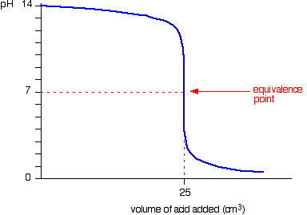

Strong Acid and Strong Bases - Running alkali into the acid

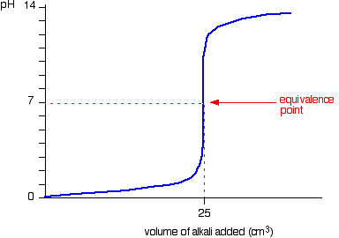

Strong acid v weak base - Running acid into the alkali

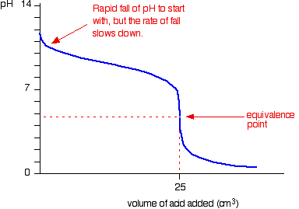

Strong acid v weak base - Running alkali into the acid
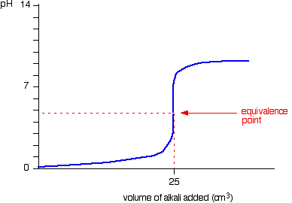

Weak acid v strong base - Running acid into the alkali

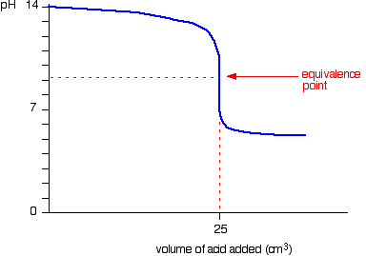

Weak acid v strong base - Running alkali into the acid

